|  |  |  |
| --- | --- | --- |
|  |  | problem sheet  Date : 29.10.2020 |

# activity 1

Wire a python program to check whether the entered character is an

Alphabet (a-z, A-Z) or not.

Input: Given Character: ‘A’

Output: The given character is an alphabet

Input: Given Character: ‘0’

Output: The given character is not an alphabet

ALGORITHM:

1. Start
2. Read x as a character
3. If asci code of x is greater than and equal to 65 and less than equal to 95 or greater than and equal to 97 and less than equal to 122 print the character is an alphabet

Else print the character is not an alphabet.

1. stop

FLOWCHART:

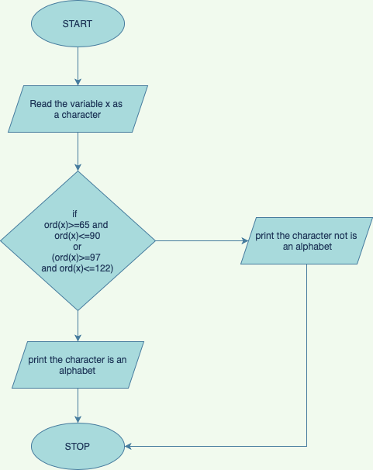

PROGRAM: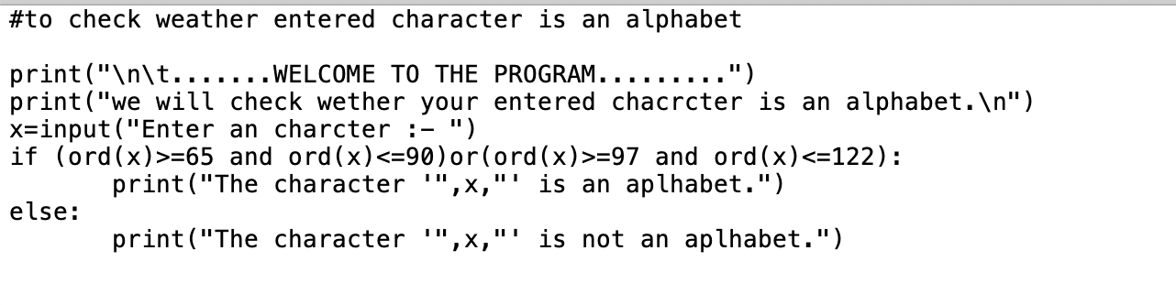

OUTPUT:

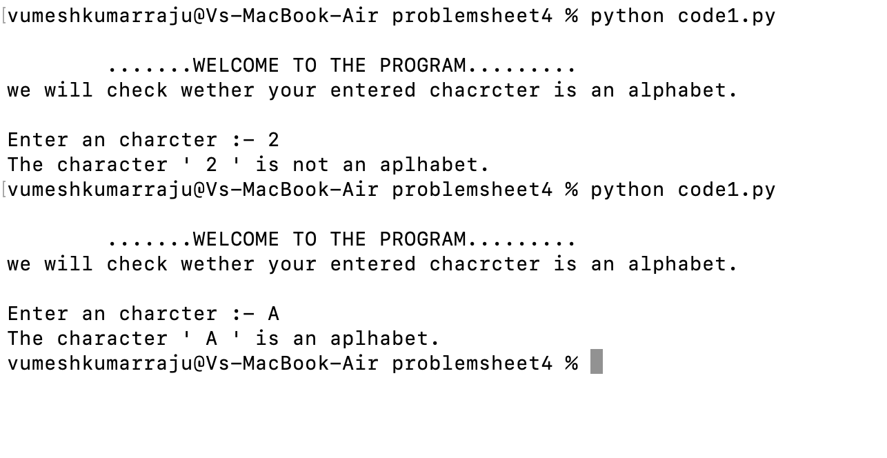

# activity 2

Write a python program to check whether the input number is prime or not.

ALGORITHM:

1. Start
2. Read x as an integer.
3. If x is equal to 1

Print 1 is neither prime nor composite number

Else

1. Initialsie i=2
2. Until i < x check if x%i is eual to zero(when x dived by i reminder is zero) then print x is a not a prime number and end further checking and iteration by break.
3. Else print x is a prime number.
4. Stop

FLOWCHART:

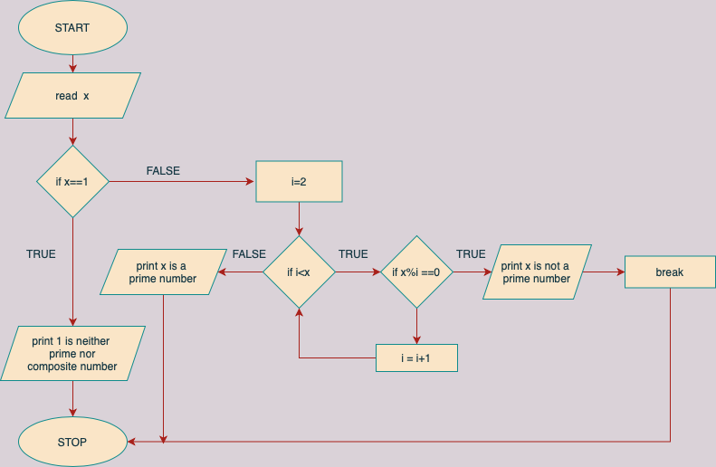

PROGRAM:

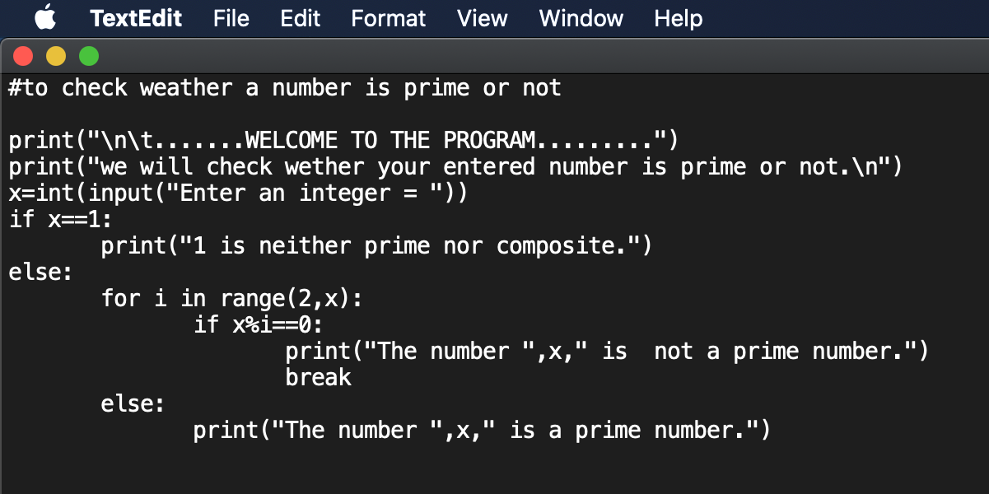

OUTPUT:

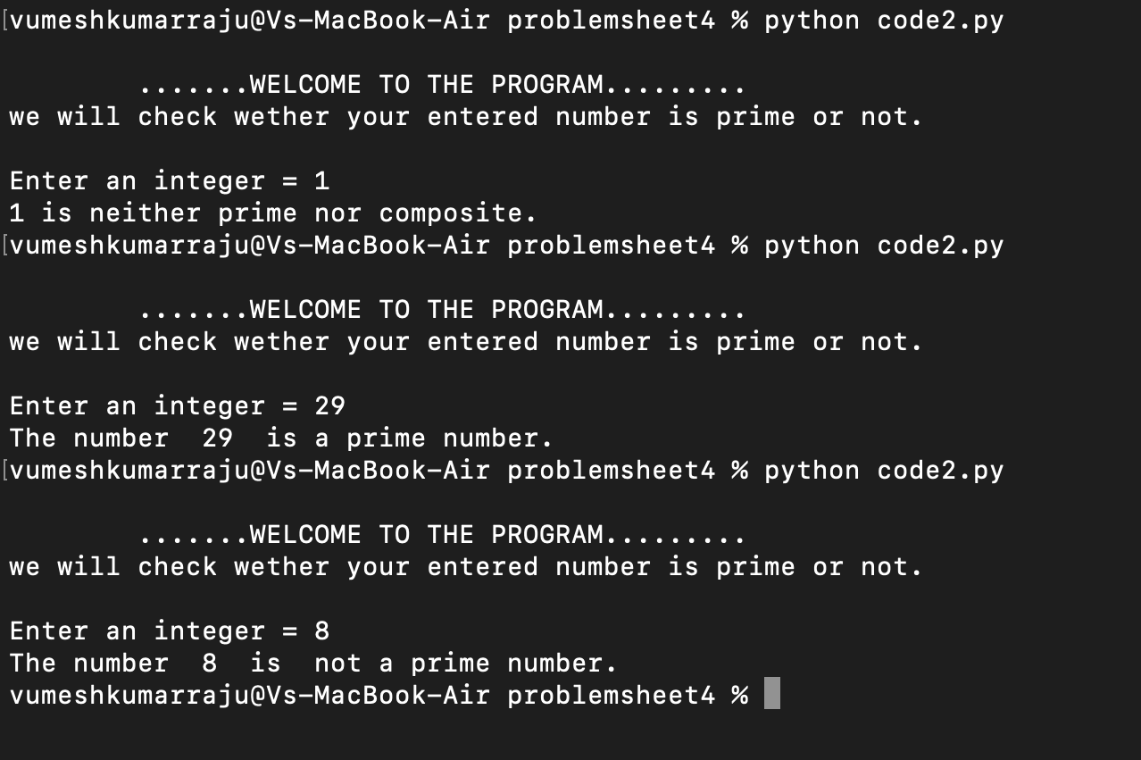

# activity 3

Write a python program to check whether the given year is leap year or not.

ALGORITHM:

1. Start
2. Read yr as year
3. if yr has no reminder when divisible by 4 (yr%4==0) and yr has no reminder when divisible by 100 (yr%100!=0) or yr has no reminder when divisible by 400 (yr%400==0)

Else print yr is not leap year.

1. Stop

FLOWCHART:

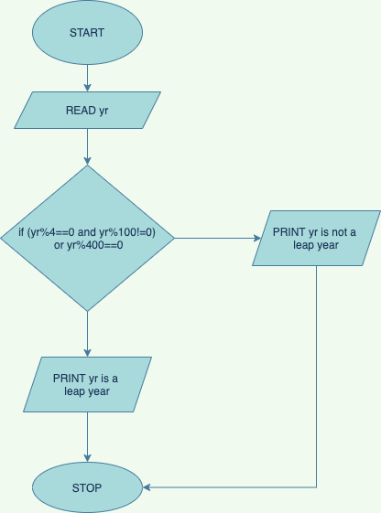

PROGRAM:

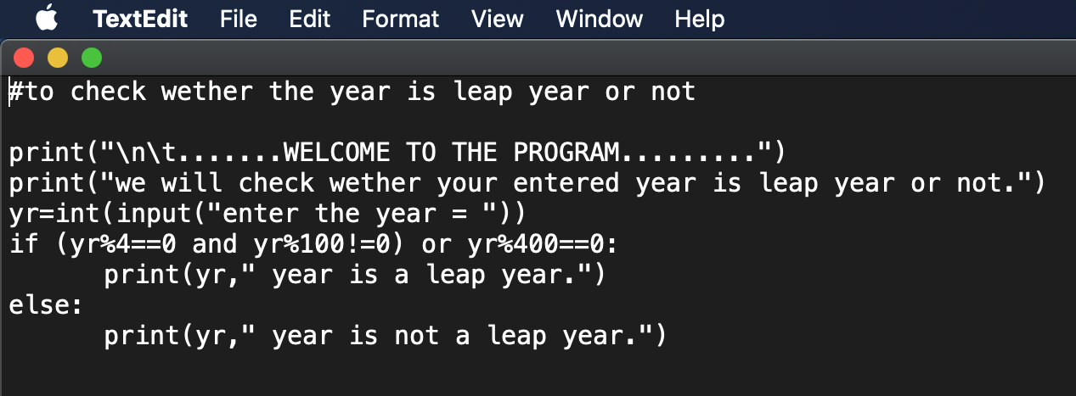

OUTPUT:

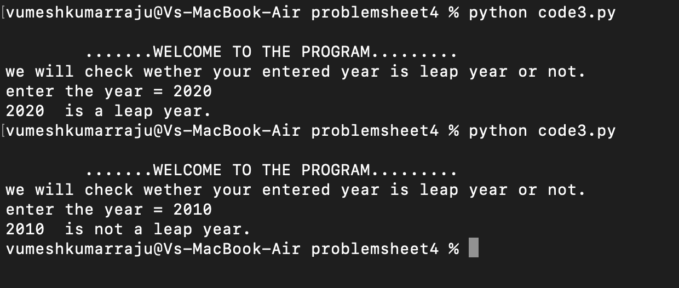

# activity 4

write a Python program to get a string made of the first 7 and the last 2 characters from a given a string. If the string length is less than 7, print error message like “String size is not sufficient”.

Sample String : India is our country

Expected Result : India iry

Sample String : VIT

Expected Result : String size is not sufficient

ALGORITHM:

1. Start
2. Read string as the string to check and modify
3. Check if length of the string is greater than equal to 7
   * + 1. Assign new_string as the string of indices starting from 0 to 7 and the string of indices starting from (length of string -2) to last and print new_string.

Else print string size is not sufficient.

1. Stop

FLOWCHART:

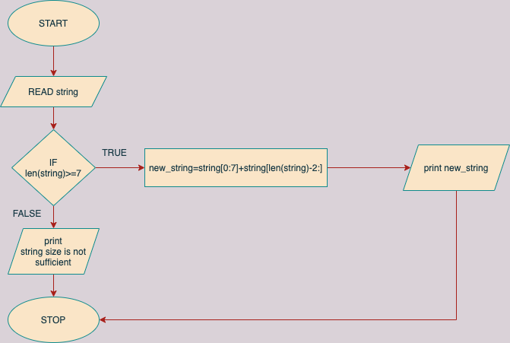

PROGRAM:

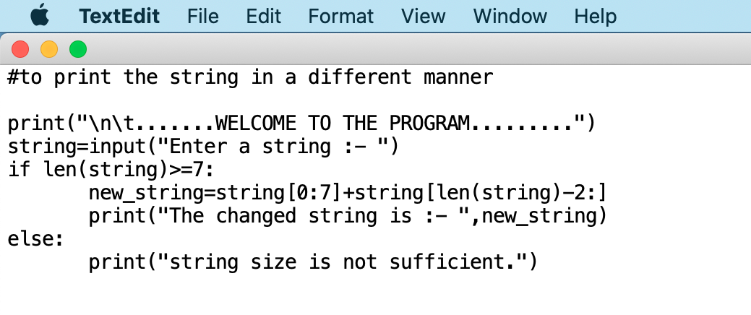

OUTPUT:

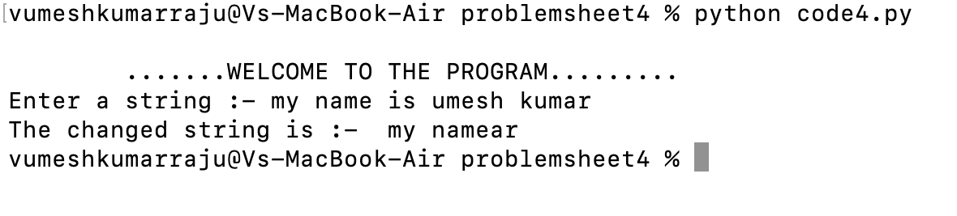

# activity 5

Write a python program to get a single string form two given string separated by a space and swap the first two characters of each string.

Sample String : 'Ajith', 'Kumar'

Expected Result : 'Kumar Ajith'

ALGORITHM:

1. Start
2. Read string1 as one string and string2 as another.
3. Assign s = “ “(a white space)
4. Print string2 and s and string1 together with concatenation operator. (string2+s+string1)
5. Stop

FLOWCHART:

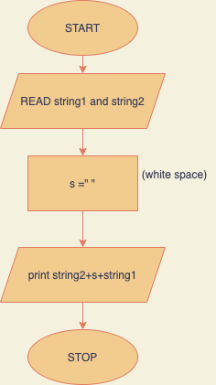

PROGRAM:

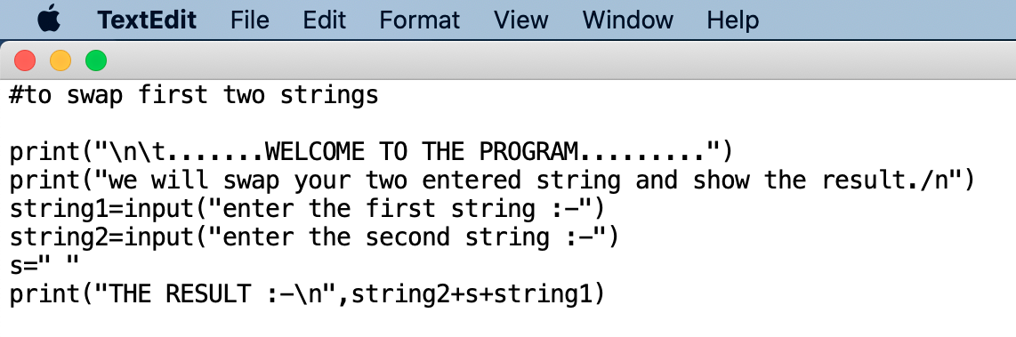

OUTPUT:

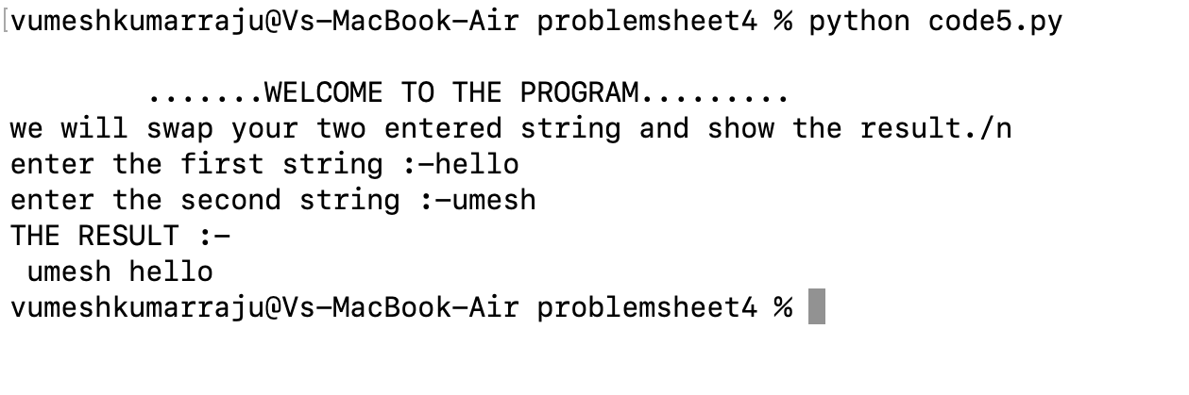

# activity 6

Write a python program to swap two integer numbers using only two variables. Temporary variables should not be used.

ALGORITHM:

1. Start
2. Read a and b two integer
3. Assign

a=a+b

b=a-b

a=a-b

1. Print the value of a and b (the swapping values)

FLOWCHART:

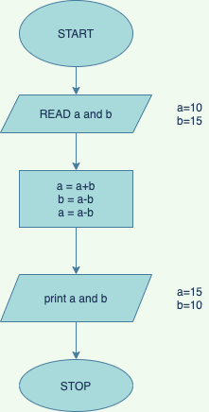

PROGRAM:

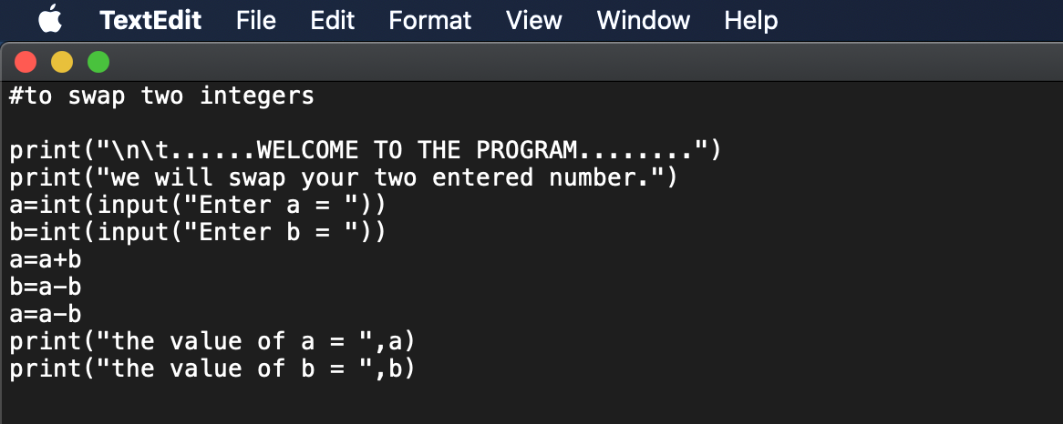

OUTPUT:

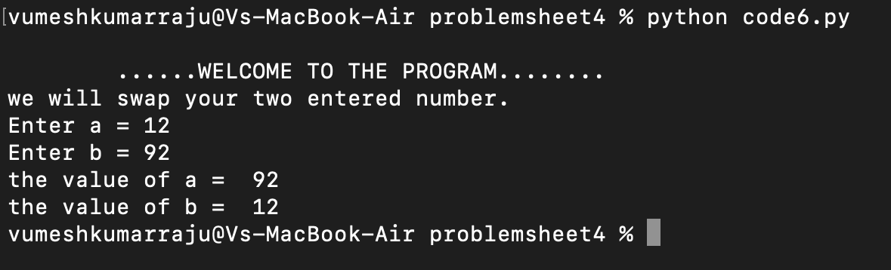

# activity 7

Print the following pattern using while loop.

Number of rows: 5

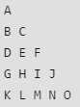

ALGORITHM:

1. Start
2. Read line as number of lines.
3. Initialize a = 65 , i = 1
4. while i less than equal to line
5. initialize j = 1
6. while j < = i

* print the alphabet having ascii value a and at end a space character.
* Update j =j+1 and a=a+1

1. Print a new line and update i = i +1.
2. Stop

FLOWCHART:

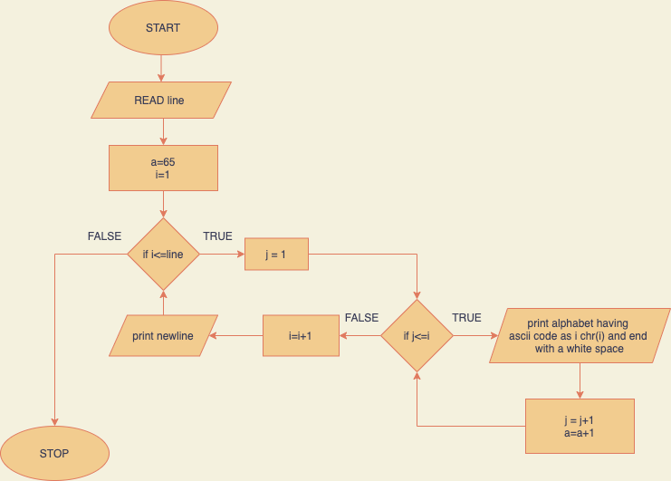

PROGRAM:

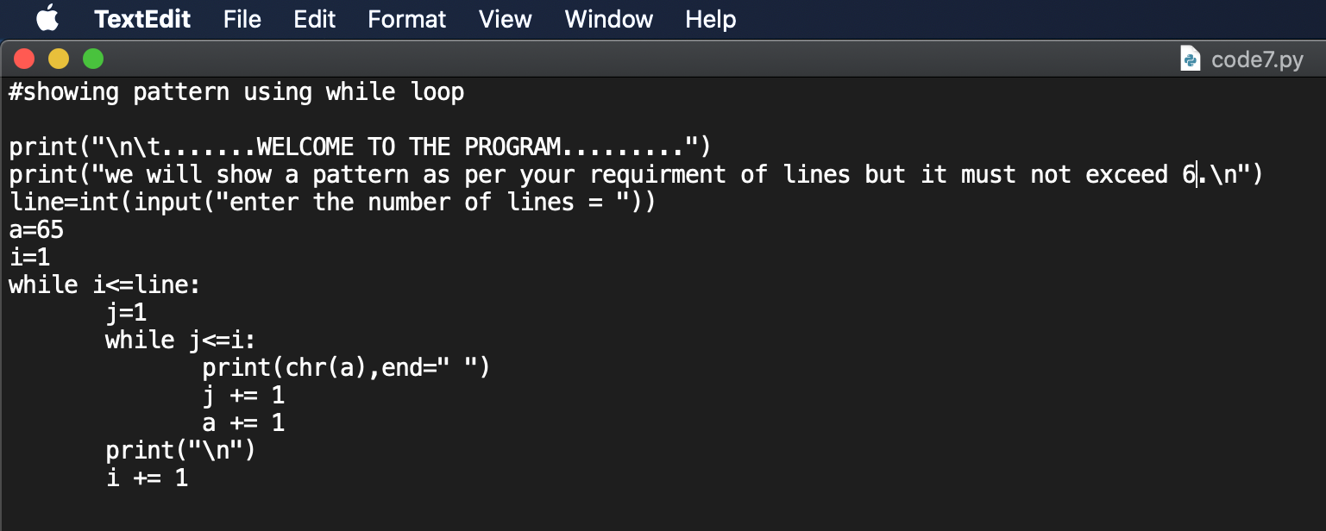

OUTPUT:

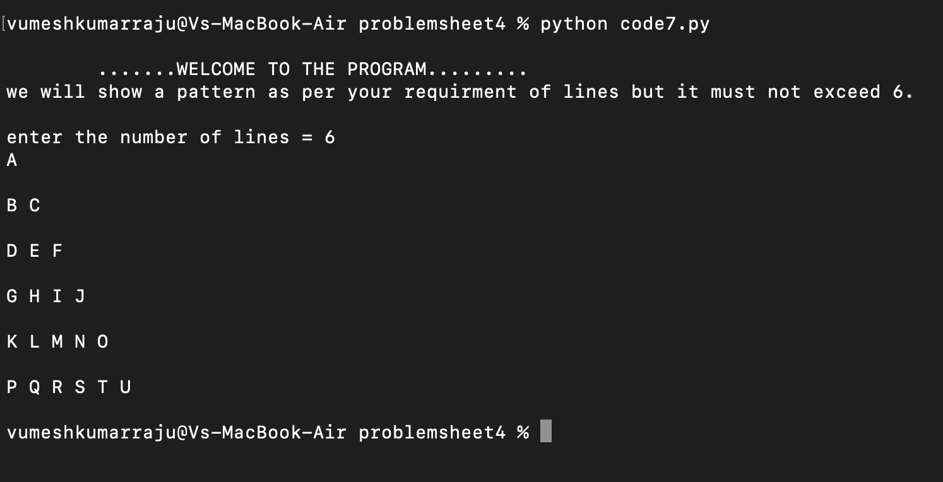

# activity 8

Print the following pattern using for loop.

Number of rows: 3

page2image45093760

ALGORITHM:

1. Start
2. Read as line number of lines.
3. Assign a=65
4. Till i is in the range of 1 to line+1 (incrementing i by 1 in each iteration)
   * + - 1. Till j in the range 0 to i print the alphabet having ascii value a and at end a space character.

Print a new line.

1. Stop

FLOWCHART:

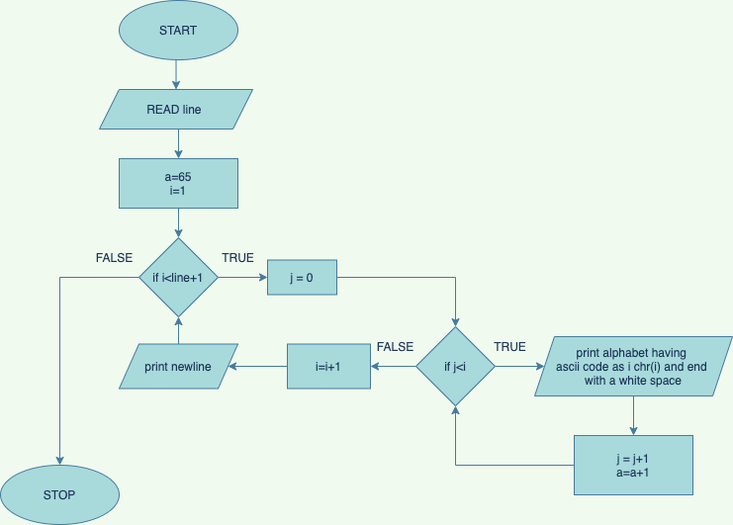

PROGRAM:

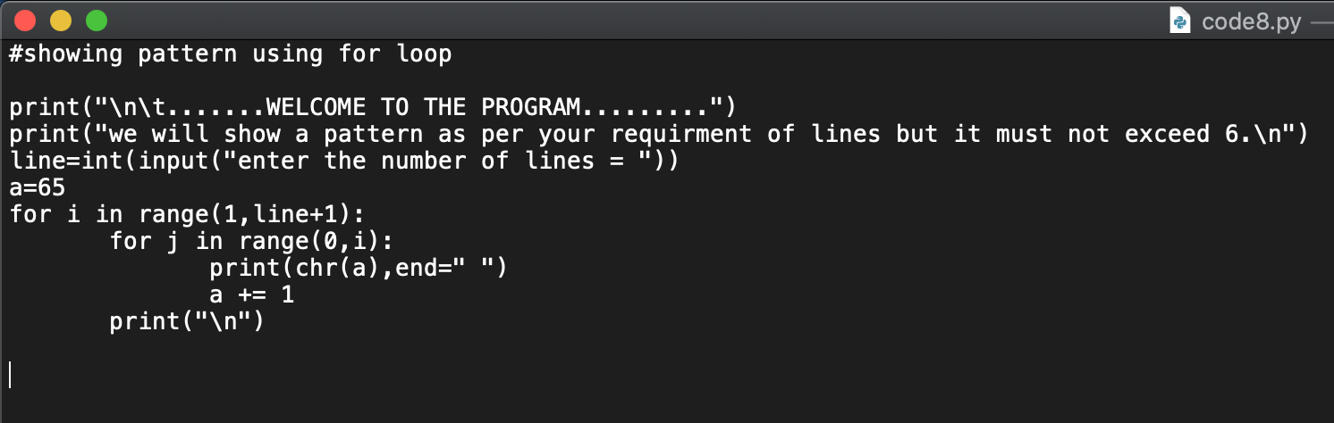

OUTPUT:

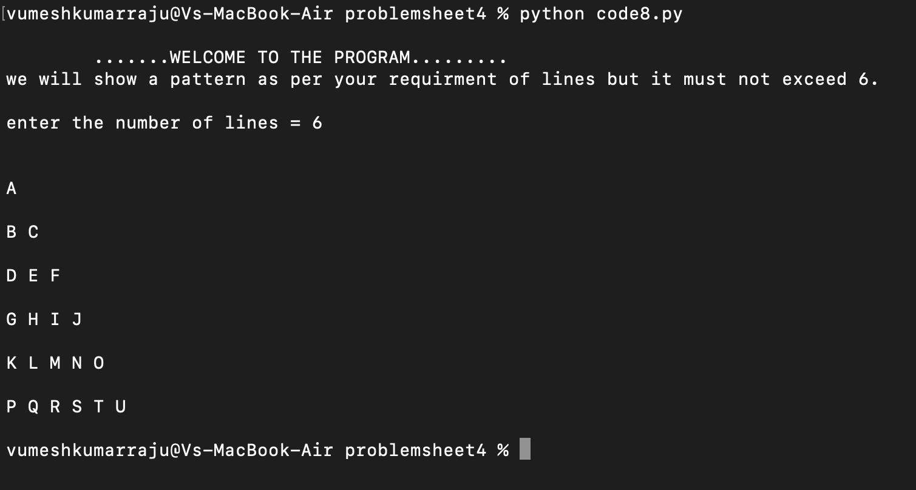

# activity 9

Write a python program to print the following pattern using while loop.

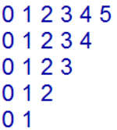

ALGORITHM:

1. Start
2. Read line as number of lines for the pattern.
3. Initialize i = line
4. While i is greater than equal to 1
   1. Initialize j=0
   2. While j is less than equal to i

Print j end with a white space and update j = j+1

* 1. Print a new line and update i = i-1

1. Stop

FLOWCHART:

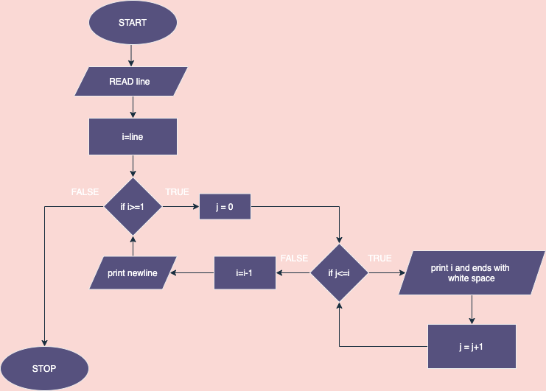

PROGRAM:

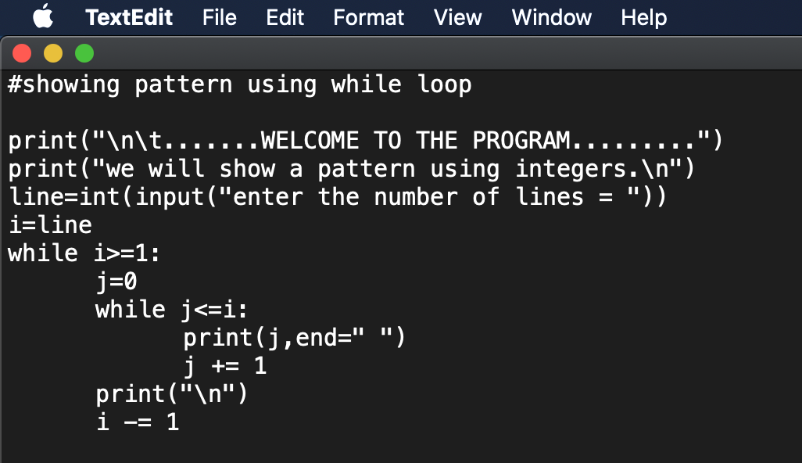

OUTPUT:

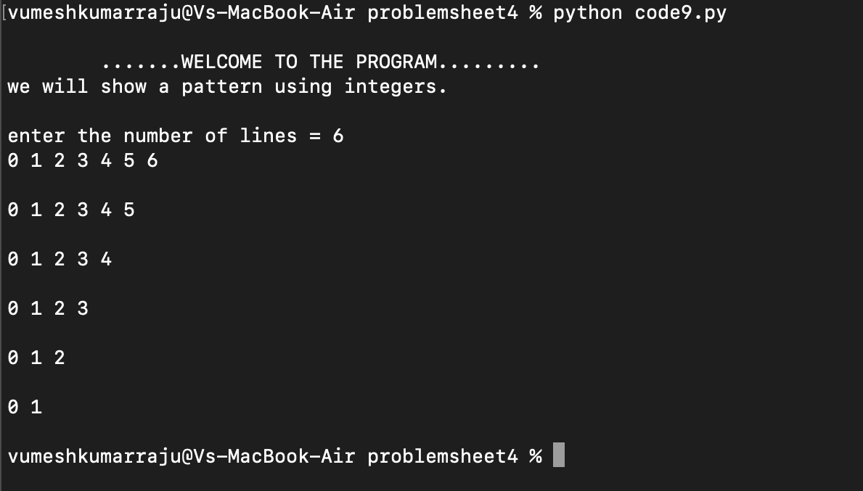

# activity 10

Write a python program to print the following pattern using for loop.



ALGORITHM:

1. Start
2. Read line as the number of lines of patterns
3. Till i is in the range of line to 0(decrementing i by 1 in each iteration)
   * + 1. Till j in the range of 0 to i+1

* Print j end with white space
  + - 1. Print a new line

1. Stop

FLOWCHART:

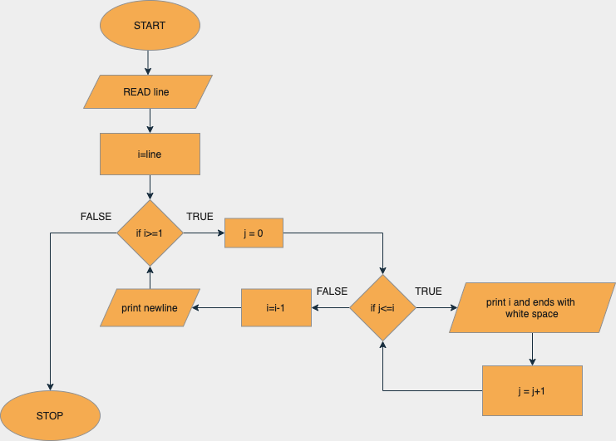

PROGRAM:

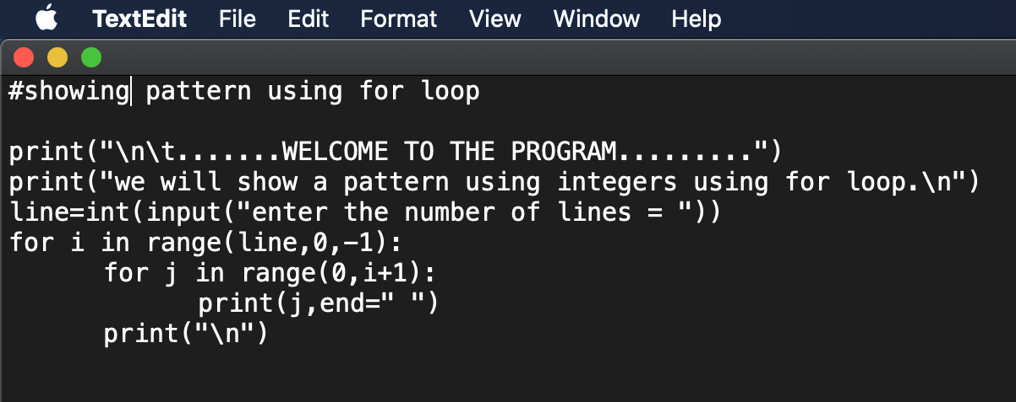

OUTPUT:

